Recommender



Predicting whether you will like something is a common job for machine learning. This is how online shops recommend what you might like to buy, video sites recommend what you might like to watch, and music apps recommend what you might like to listen to.

In this project, you will investigate whether it’s possible to judge a book by its cover. You will make a project in Scratch to see if a computer can learn to predict whether you would want to read a book, based only on what the cover looks like.

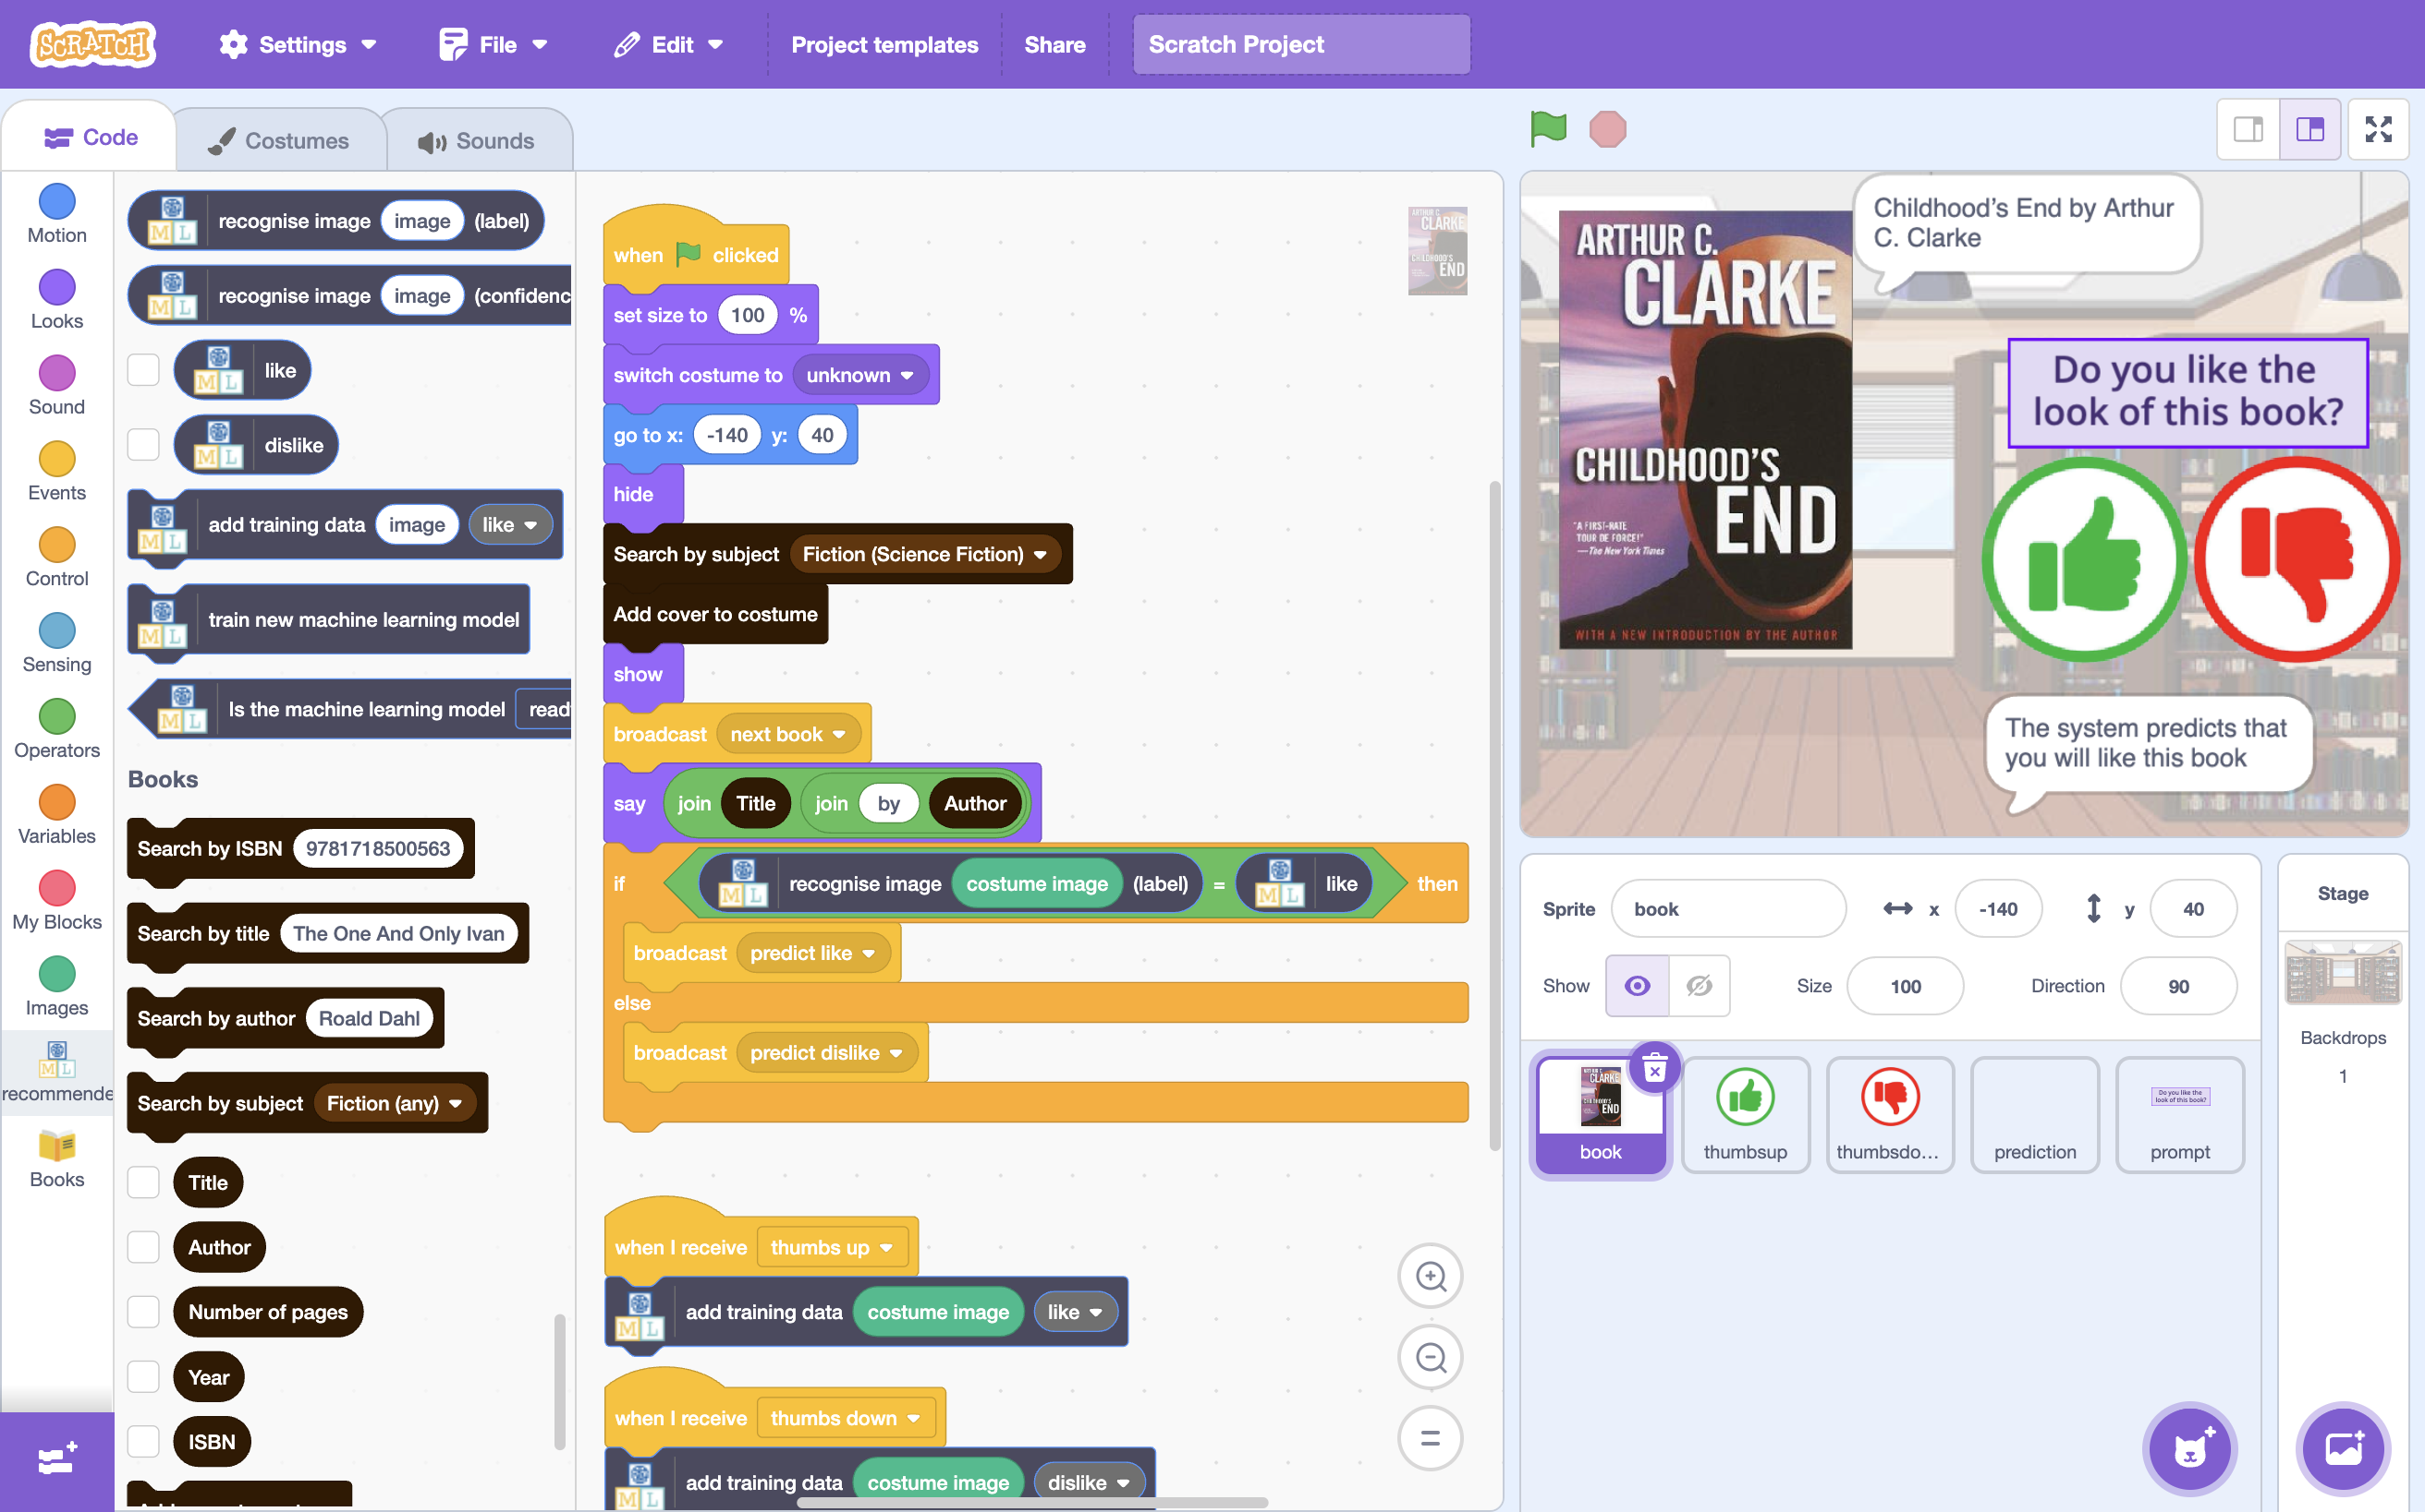

This project worksheet is licensed under a Creative Commons Attribution Non-Commercial Share-Alike License

http://creativecommons.org/licenses/by-nc-sa/4.0/

1. Go to <https://machinelearningforkids.co.uk/> in a web browser
2. Click on “**Get started**”
3. Click on “**Try it now**”
4. Click on “**Projects**” on the top menu bar
5. Click the **“+ Add a new project**” button.
6. Name your project “recommender” and set it to learn how to recognise “**images**”. Click “**Create**”  
   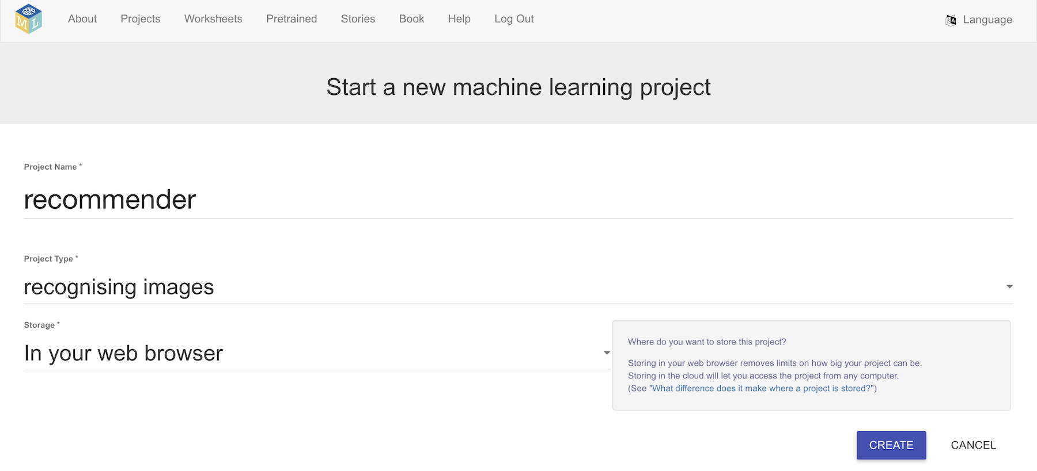
7. You should now see “**recommender**” in your projects list. Click on it.
8. Click the “**Train**” button  
   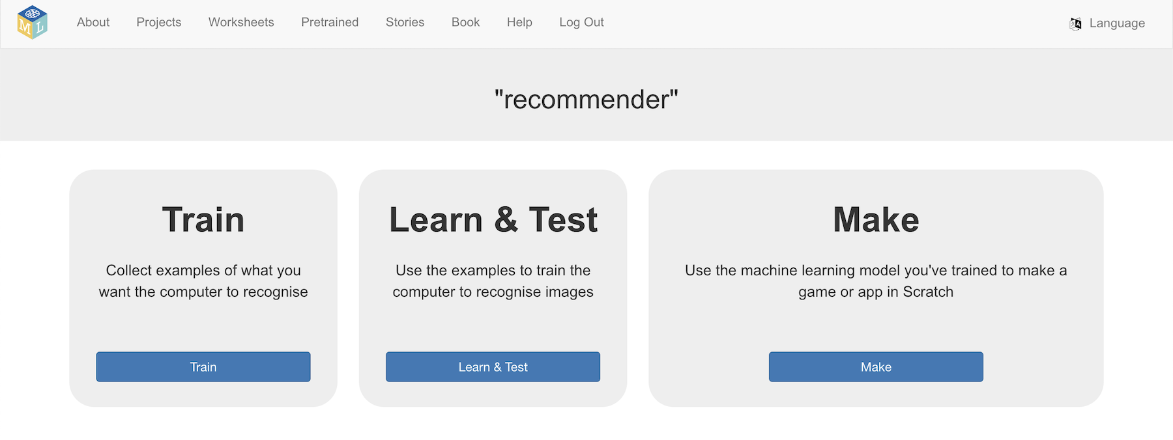
9. Use the “**+ Add new label**” button to create two buckets  
   *One for books with covers that you like: “****like****”  
   One for books with covers that you don’t like: “****dislike****”*  
   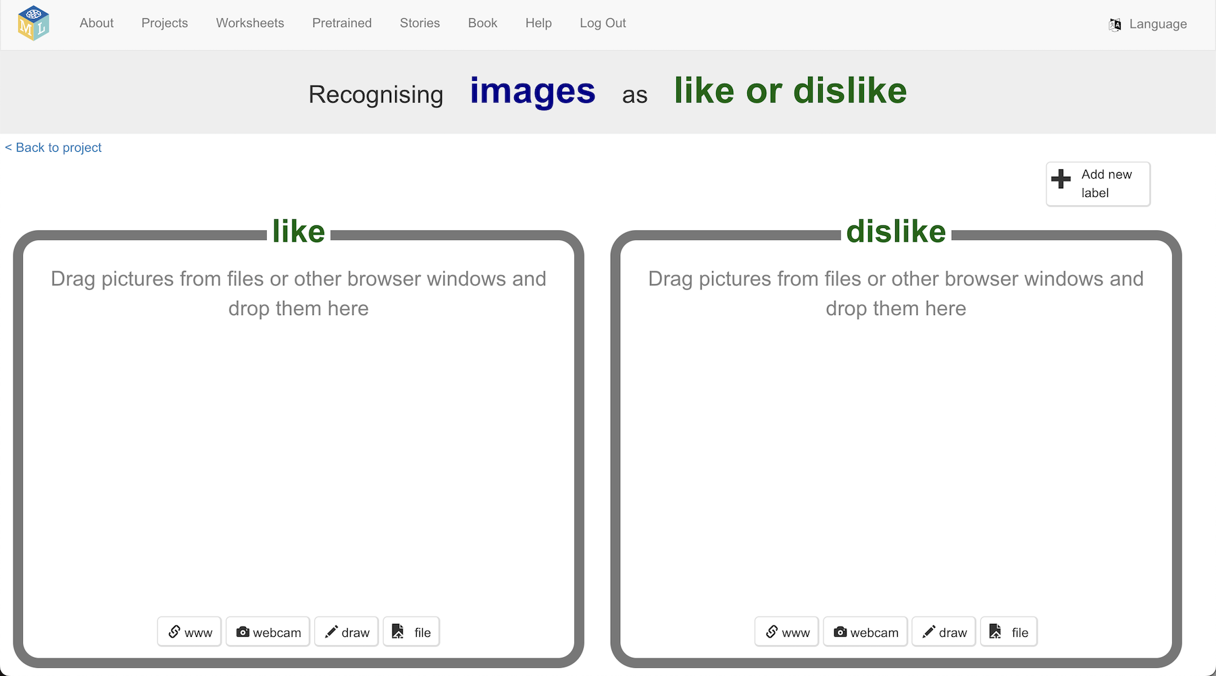
10. Click the “**< Back to project**” link.
11. Click the “**Make**” button
12. Click the “**Scratch 3**” then click “**straight into Scratch**”  
    *The page will warn you that you haven’t trained a machine learning model yet. That is okay, as you will be using Scratch to collect training images.*
13. In the Scratch window, click on “**Project templates**”  
    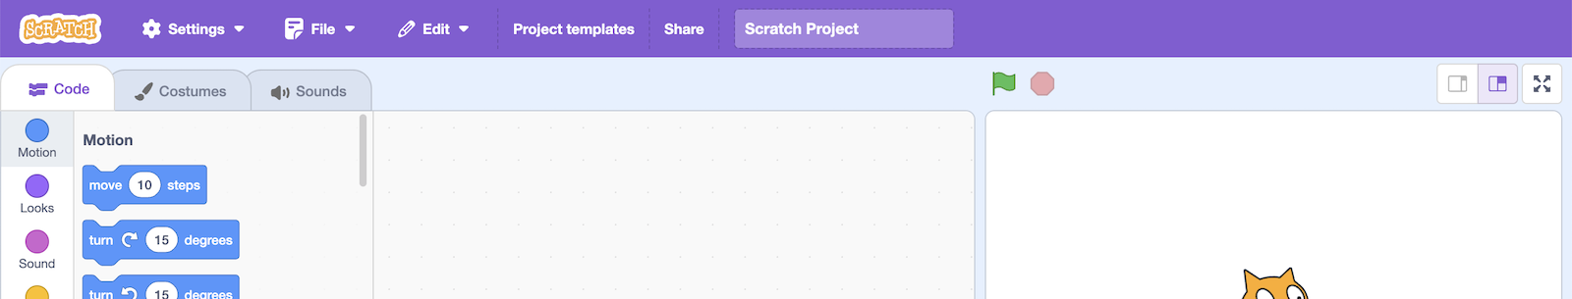
14. Click on the “**Recommender**” template
15. Open the extensions list  
    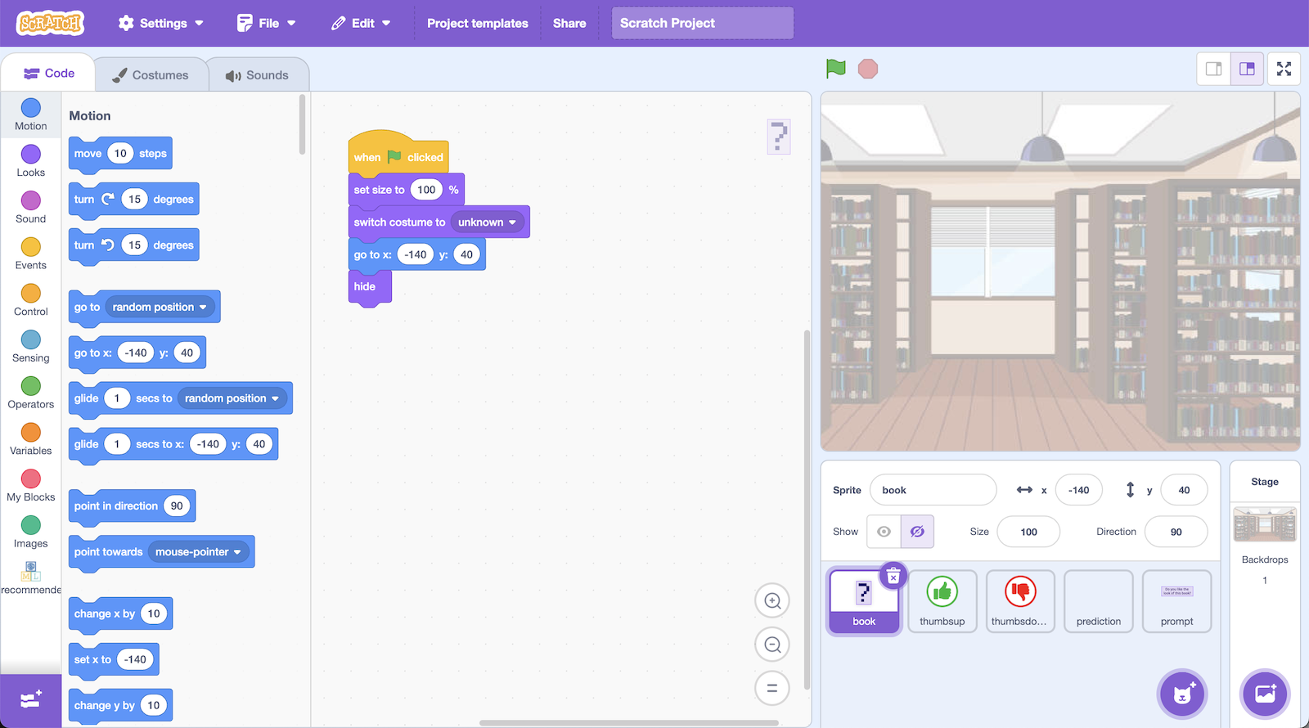
16. Add the “**Books**” extension to your project  
    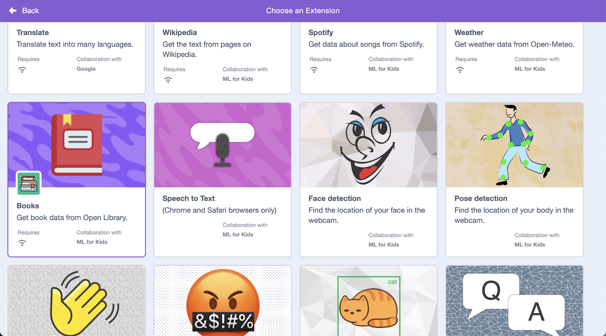
17. Choose a book subject to use for this project  
    *In this project, you will be shown covers from random books, and asked to choose whether you would want to read it.   
    In the screenshots below, I decided to base my project on Science Fiction books, but you can choose your own subject.*
18. Click on the “**book**” sprite  
    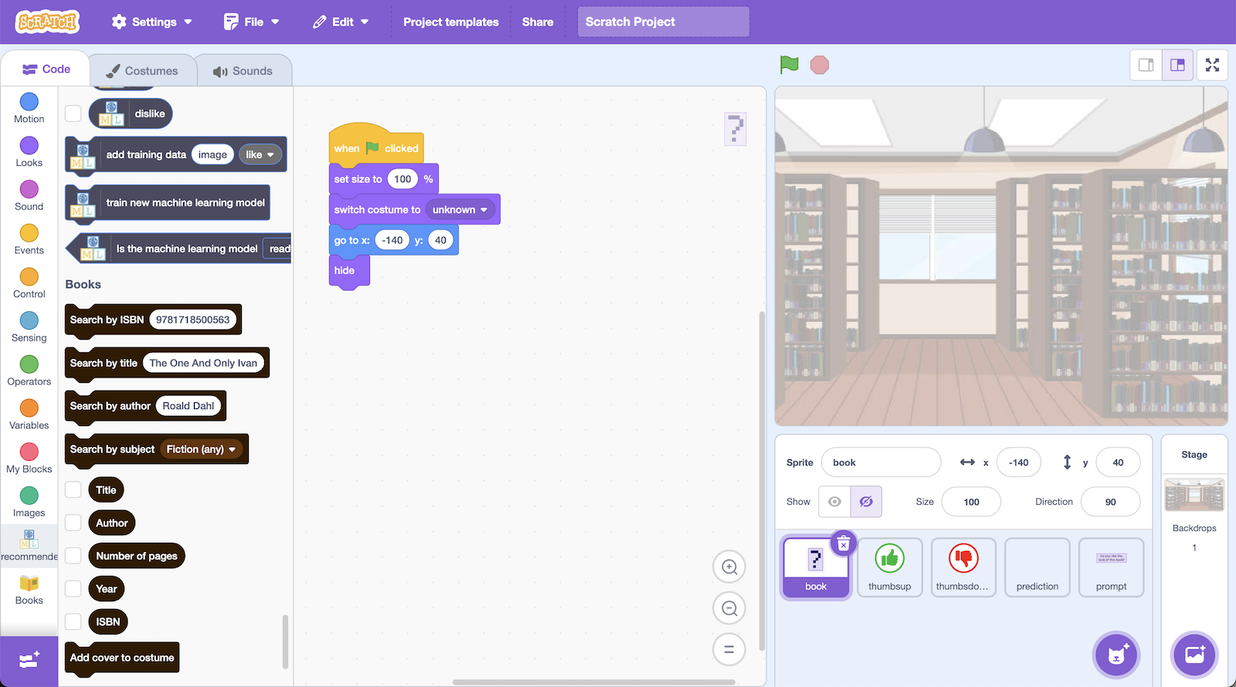
19. **Update** the code that is there so that it looks like this:  
    *The first four blocks are already in the template for you.  
      
    In the “****Search by subject****” block, choose a subject you would like to use.*   
    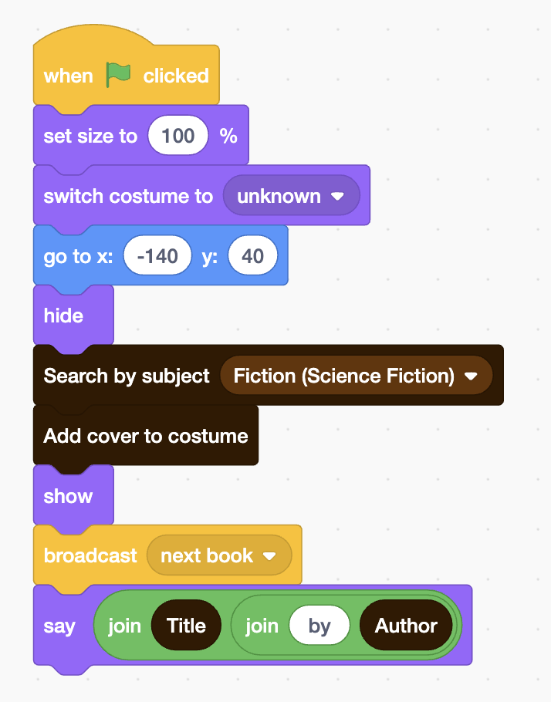
20. Add this code   
    *You should still be in the “book” sprite*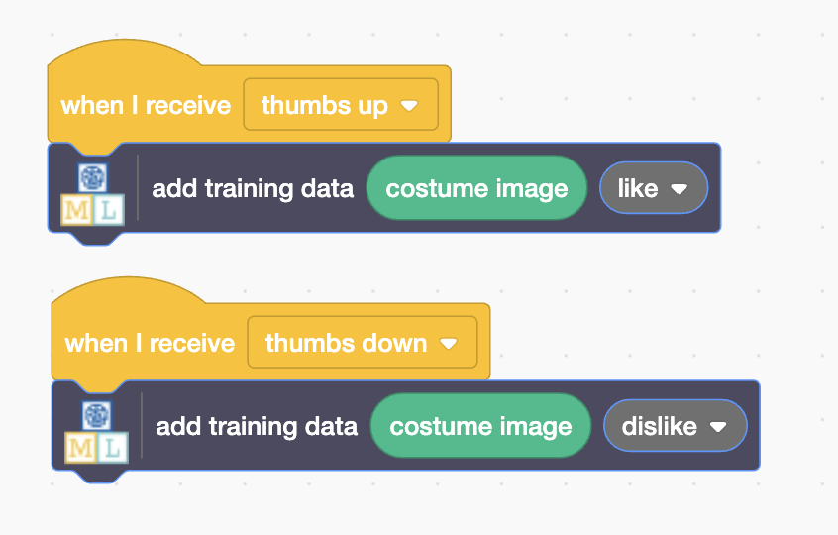
21. Click on the full-screen button then click on the Green Flag  
    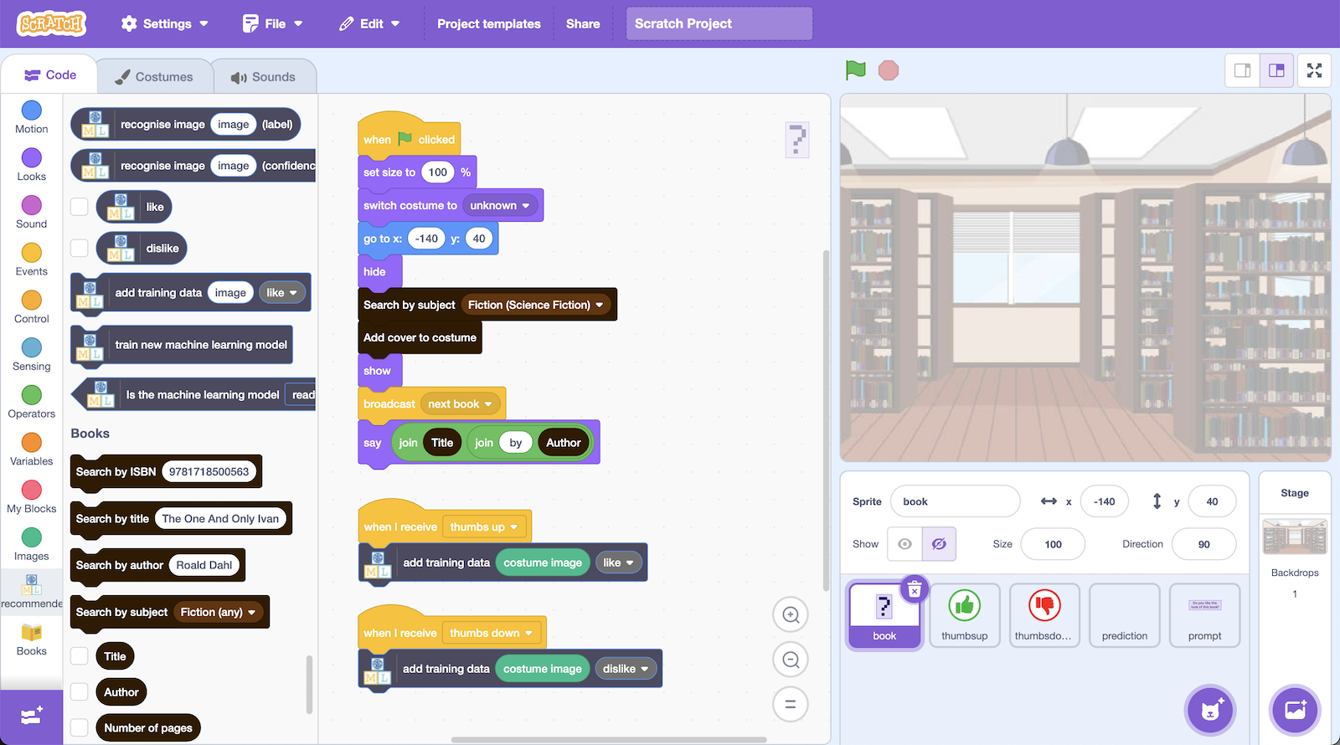
22. You will see a random book cover.   
    Imagine you saw this book on a shelf. Would you give it a try?   
    If you like the look of it, click thumbs up. Else, click thumbs down.  
    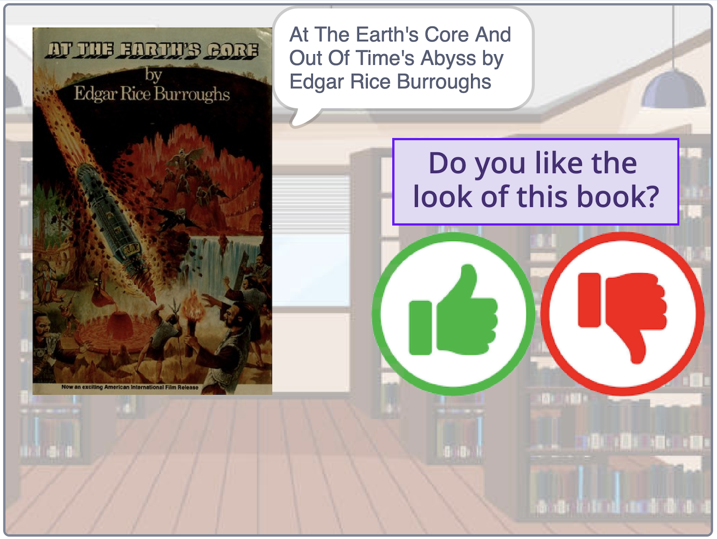

Sometimes a cover can’t be found, so you will just see a question mark.  
   
If this happens, click the Green Flag again to try a new book.

1. In the training window, click on the “**< Back to project**” link and then go back to the “**Train**” screen  
   *You should see the book from Scratch in one of your training buckets.  
   If it is not there, go back to steps 19 and 20, and check your code.*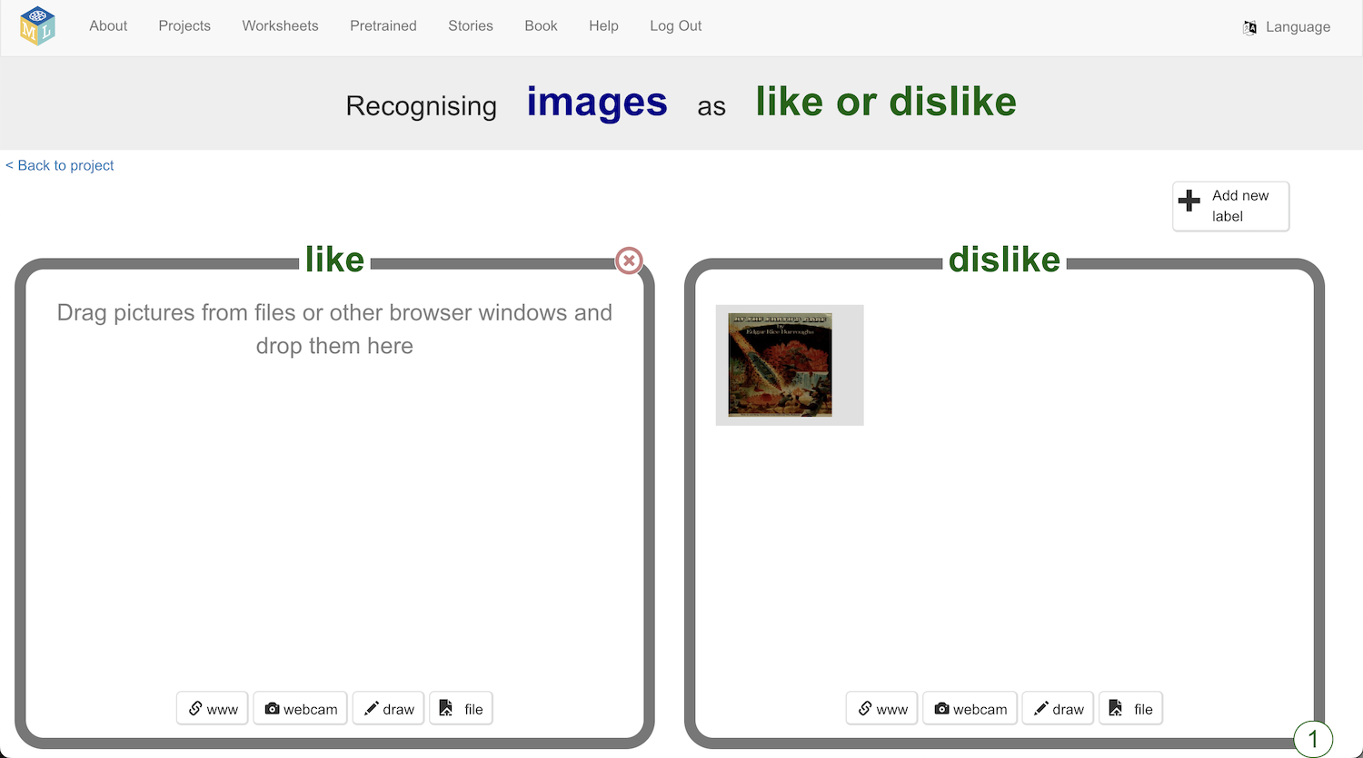
2. In the Scratch window, click the **Green Flag** to try another book.  
   *If you see the same book again, skip it by clicking the Green Flag again.  
   Imagine you saw this book on a shelf. Would you give it a try?*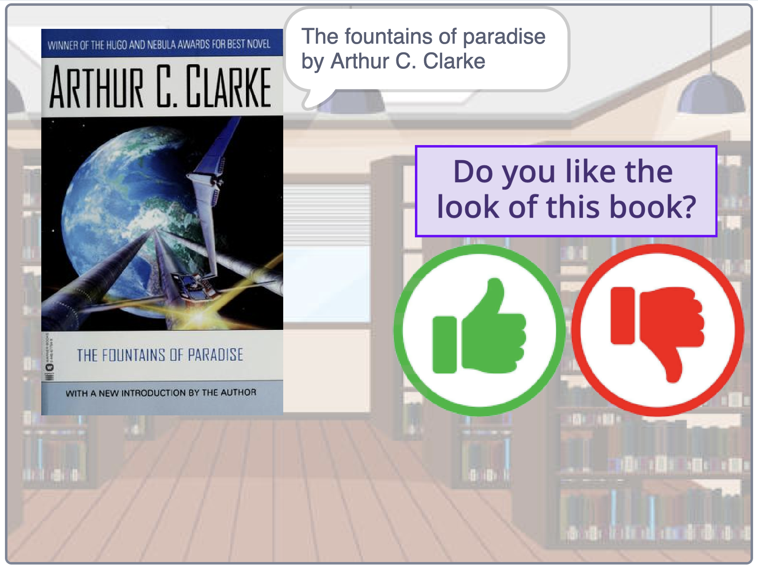
3. Keep going!  
   *Click on the Green Flag to get the next book, then choose one of the buttons.   
   You want to collect a variety of examples of books that you would try reading, and a variety of examples of books that you don’t like the look of.  
   Try to avoid duplicates when you see books you remember seeing before.*
4. Use the training tool to keep track of how many examples you have  
   *Once you have at least ten examples for both like and dislike, you can continue to the next step.*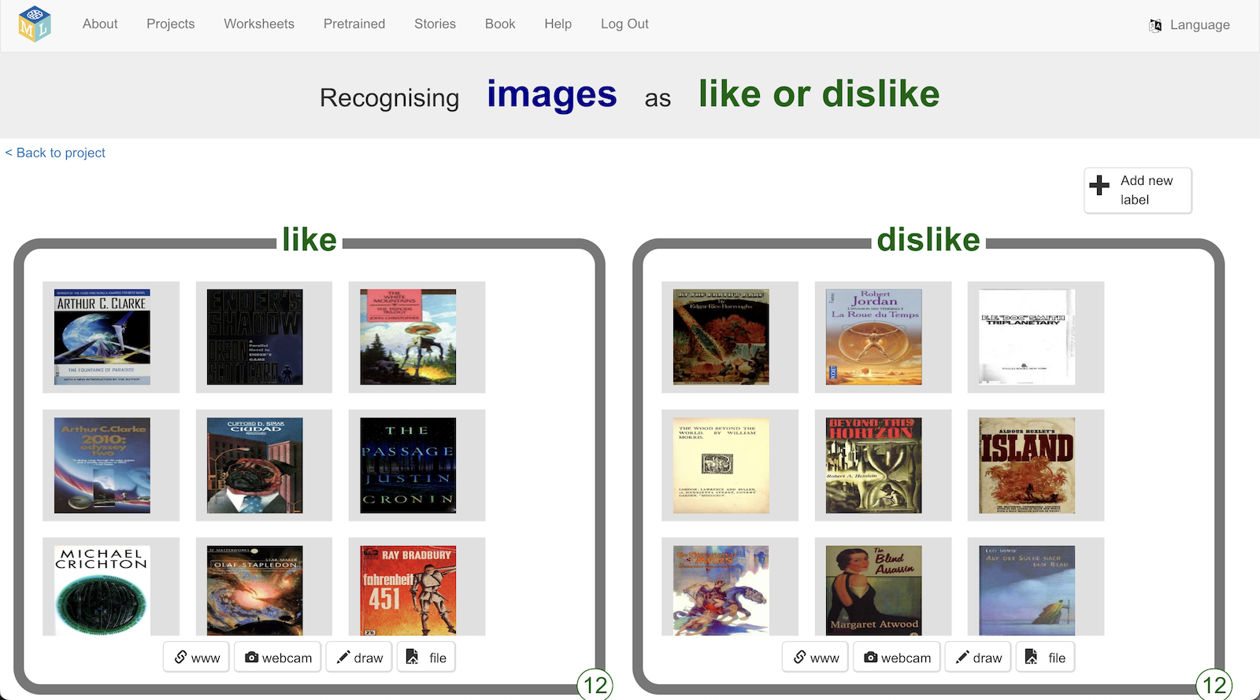
5. Click on the “**< Back to project**” link.
6. Click on the “**Learn & Test**” button
7. Click on the “**Train new machine learning model**” button  
   *The button will not be there if you don’t have enough training examples.  
   Wait for the model to finish training.*  
   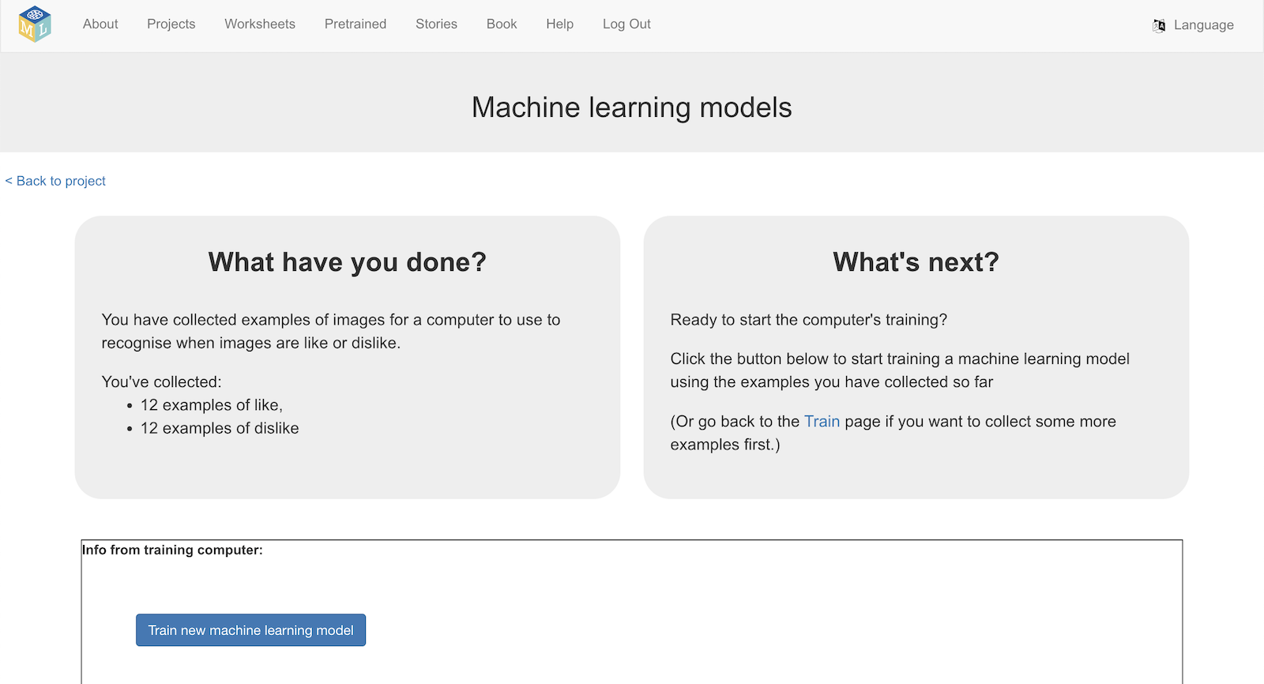
8. **Update** your Green Flag code to look like this.  
   *Still in the “****book****” sprite, the new bit is the* ***if … then … else*** *at the bottom.*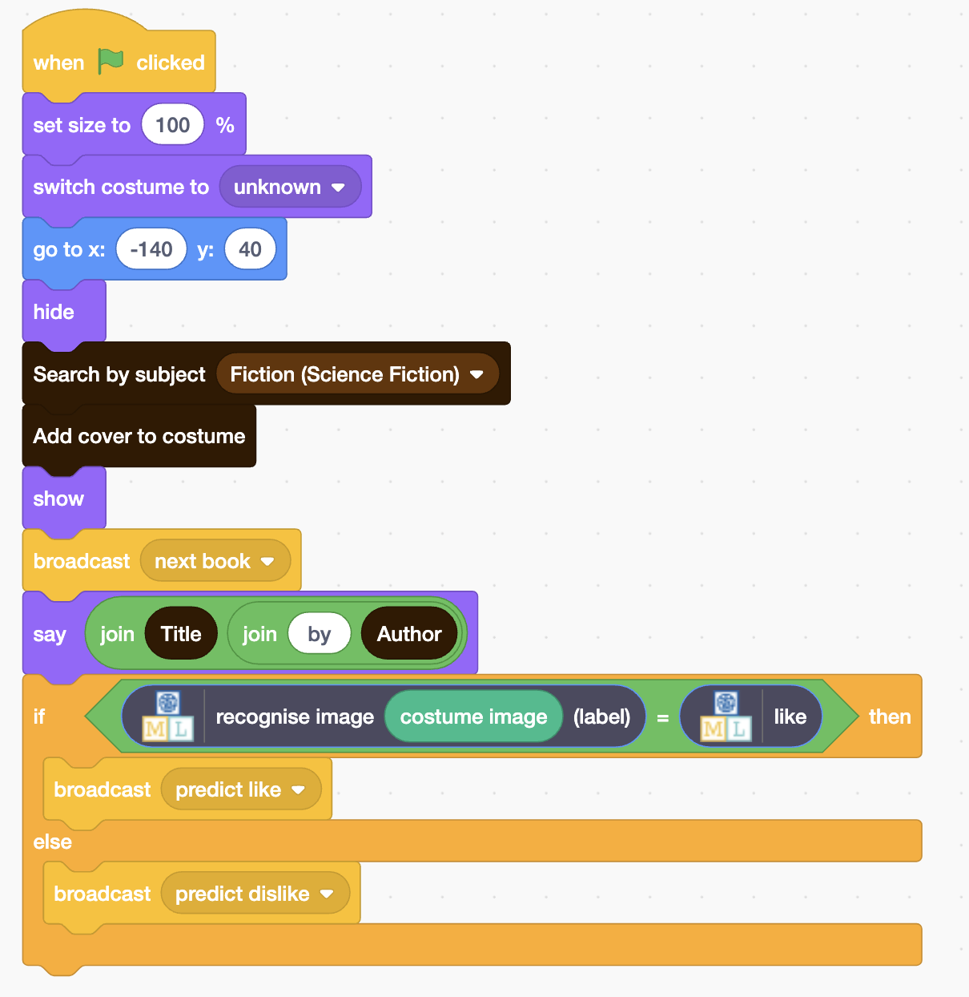
9. Click on the **full-screen** button and then the **Green Flag** like before  
   *Click* ***thumbs-up*** */* ***thumbs-down*** *buttons like before.  
   Try to avoid duplicates when you see books you remember seeing before.*  
   *This time, you will also see a prediction from your machine learning model*   
   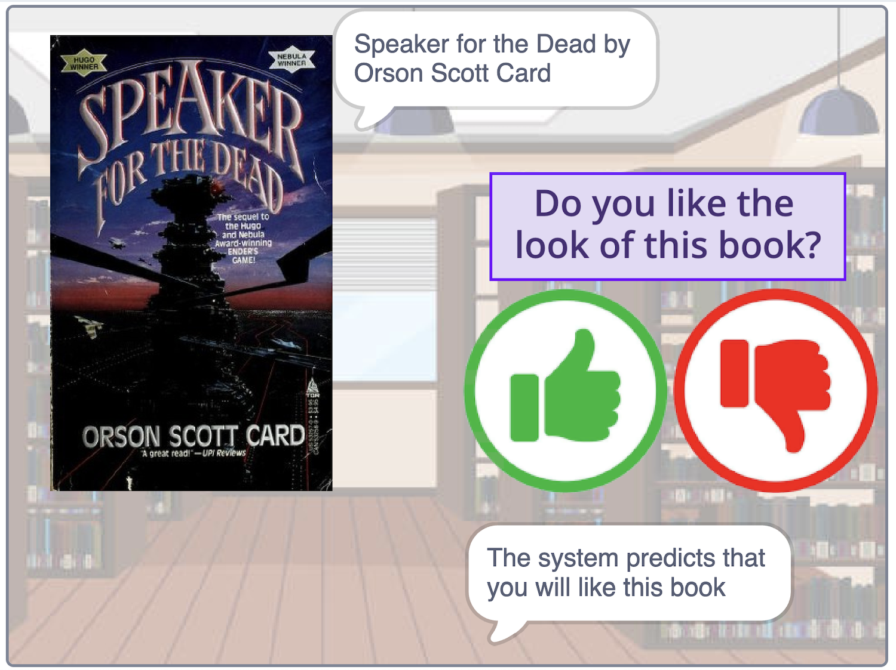

**What have you done?**

You’ve trained a machine learning model to classify pictures. The computer learned from patterns in the colours and shapes from each of the images you’ve given it. These were used to recognise new covers.

If the computer has recognised patterns in the sorts of books that you like the look, then it should be good at predicting books you might try reading.

If it hasn’t identified patterns in your answers yet, then it might still be making mistakes. Giving it more examples may help it to learn what you like.

1. When you have collected extra examples for the computer to learn from, you should train a new model.   
   *In the training tool, click the “****Train new machine learning model****” button.*  
   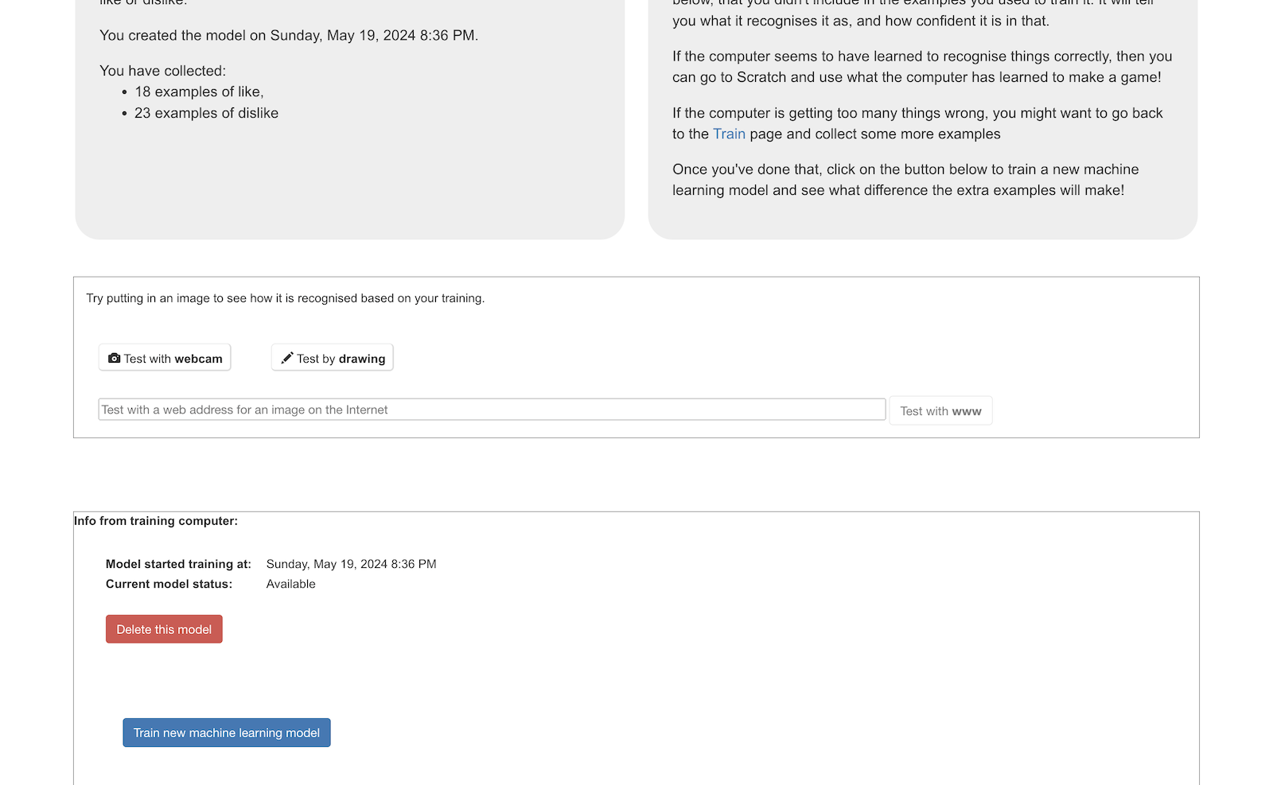
2. Go back to the Scratch window  
   *Have the extra training examples improved the predictions that the machine learning model is making?*

**Ideas and Extensions**

Now that you’ve finished, why not give one of these ideas a try?

Or come up with one of your own?

**Predict which covers you like from your favourite author**

Instead of looking at books about a particular subject, you could try basing a project on books by your favourite author.

Make sure you choose an author that has written enough books to base a project on!

Replace the search by subject block with this:  
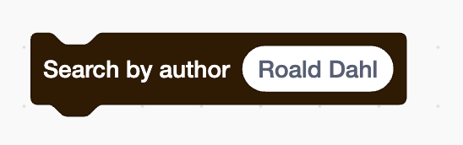

**Add a third category**

If you think two categories isn’t enough, try adding a third.

Instead of like/dislike, you could base a project on   
like / don’t mind / dislike.